## Assignment for Bot Development

Casey is a weather report Analyst lead whose team has lot of repetitive work to be done manually every day.

When we approached her with our RPA offerings she was so much excited about RPA and its capabilities and how it can reduce so much of man hours for her and her team. She wanted to see how an RPA bot works and how it can automate all of their repetitive work. We were given 2 days of time to develop an POC for one of their use case and to come up with perfectly working bot. You are now assigned the task to develop the bot and show a demo of the bot to Casey and her team.

Please find the below step by step procedures to be automated.

Step 1:

The input excel contains number of sheets with different city name.



Step 2:

Read the sheet names from the excel.



Step 3:

Navigate to <https://www.worldweatheronline.com/>

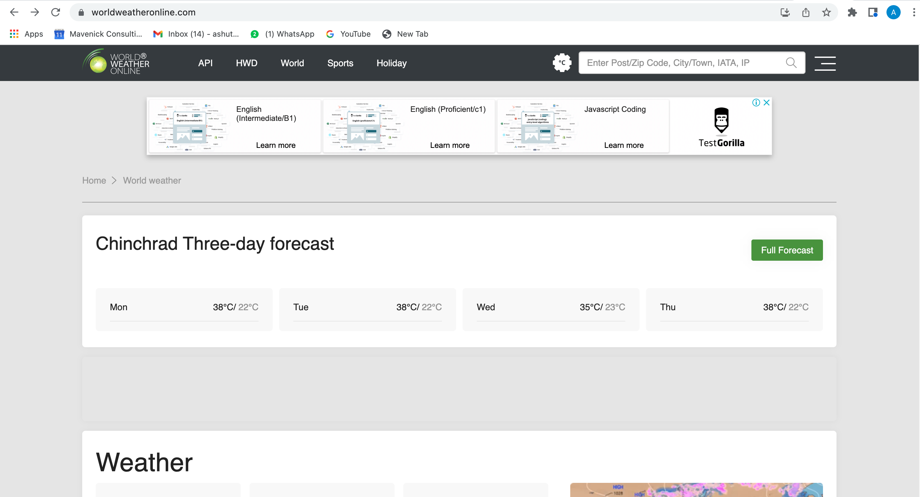

Step 4:

Enter the city name read from the excel sheet and paste it in search box. Press Enter.

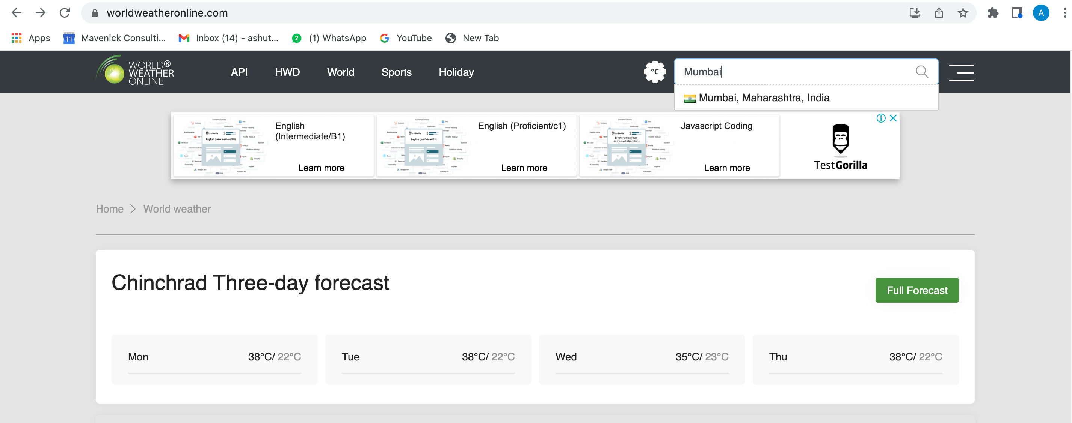

Step 5:

Extract the table containing Weather details (Wind, Rain, Cloud, Humidity, sunrise, sunset, moonrise, moonset) of the city and paste it in the respective sheets

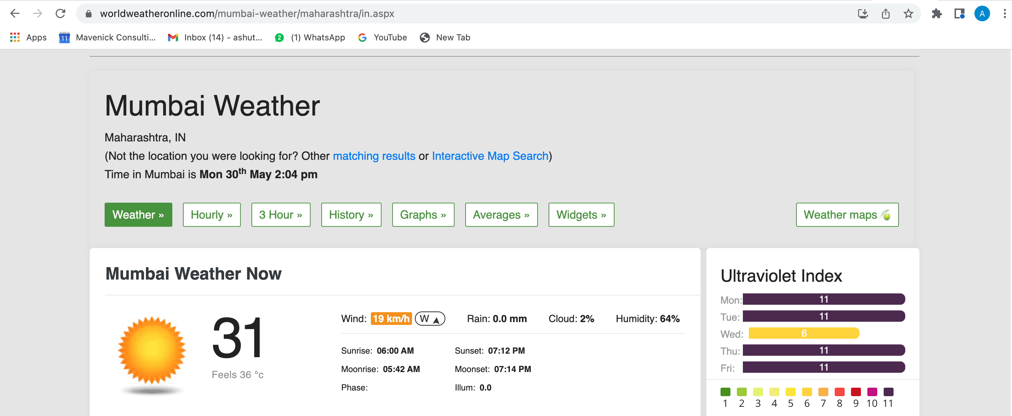

Step 6:

Create a new sheet named “Consolidated Sheet”.

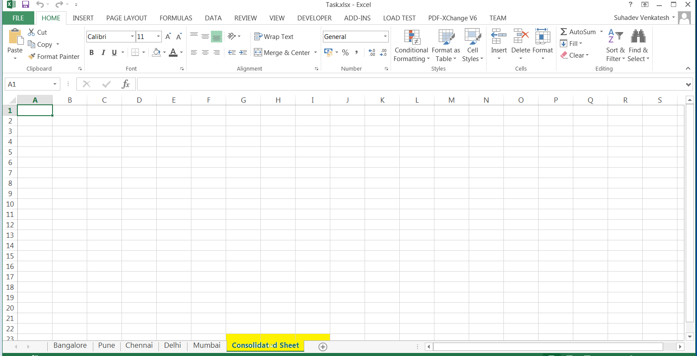

Step7:

Sort the cities in ascending order of Humidity present.

Step 8:

Create a 3D graph of your choice (using any 3D graph in Excel) to visualise the data (sorted humidity data) and display it in the consolidated sheet created by the bot.